TD1 LINUX
Part 5 - Linux navigation

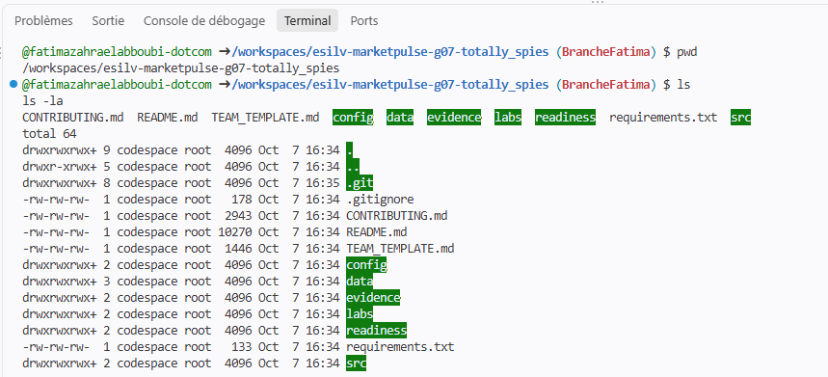

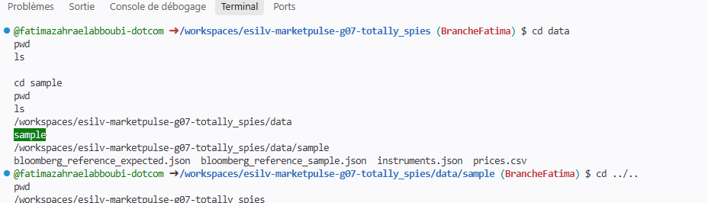

Part 6 - Inspect the starter data
  - JSON metadata

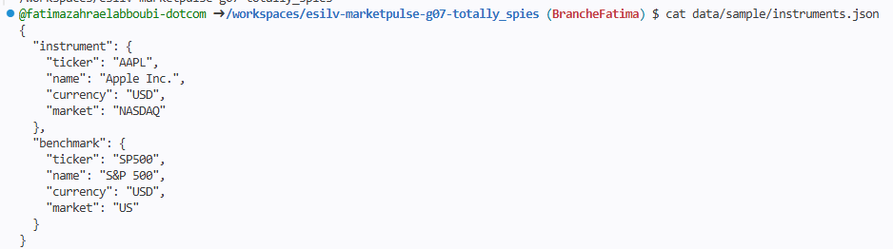
1. What is the instrument?
Apple Inc., ticker AAPL, coté au NASDAQ, en USD.
2. What is the benchmark?
Le S&P 500, ticker SP500, marché US, en USD.
3. Where are their names and tickers stored?
Dans l’objet JSON, sous deux clés : instrument et benchmark. Chacune contient ticker, name, currency et market.

6.2 CSV observations
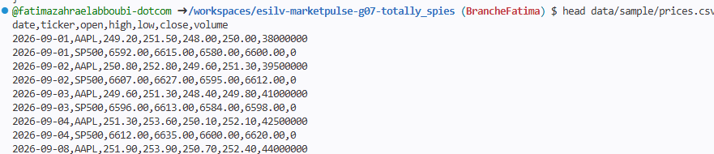

Part 7 - Verify the runtime
